

Brief overview of SQL Server upgrade

|  |  |
| --- | --- |
| Originator | Celtrak |
| Owner | Paul Roche |
| Author | Paul Roche |
| Reviewer |  |
| Version | 1.1 |
| Created Date | 28 July 2015 |
| Updated Date |  |
| DOC Id |  |
| Distribution | None |

Version Control

|  |  |  |  |
| --- | --- | --- | --- |
| Version | Issue Date | Author | Comments |
| 1.0 | 28/07/15 | Paul Roche | Initial Draft. |
|  |  |  |  |
|  |  |  |  |
|  |  |  |  |
|  |  |  |  |

Table of Contents

1.1 Overview 3

1.2 Objective 4

1.3 Benefits 4

1.4 Key Design 4

1.5 Implementation Tasks 5

1.6 Test Approach 6

1.7 Risks and Migration 6

1.8 Deployment 6

## Overview

This is a brief document to outline key points of the SQL Server upgrade that will be implemented by Celtrak.

This is not intended as a comprehensive design document.

## Objective

Upgrade existing SQL Server edition from SQL Server 2005 Standard to SQL Server 2014 Enterprise edition.

At the same time we will also upgrade the operating systems on all virtual servers hosting SQL Server.

## Benefits

This upgrade will ensure that the database solution is sufficiently scalable to cater for anticipated future growth.

Also with multiple redundancies in place, it will greatly improve the availability of the database server in the event of a systems failure.

High level summary of benefits are:

* Improved performance
* Increased scalability
* Improved business continuity
* Improved disaster recovery

## Key Design

We will be creating a new cluster that will contain:

* 4 nodes (virtual servers)
* 2 Failover Cluster Instances (FCI). There will be one in each data centre.
* 1 Availability Group (AG) between the 2 data centres.

This is illustrated below.

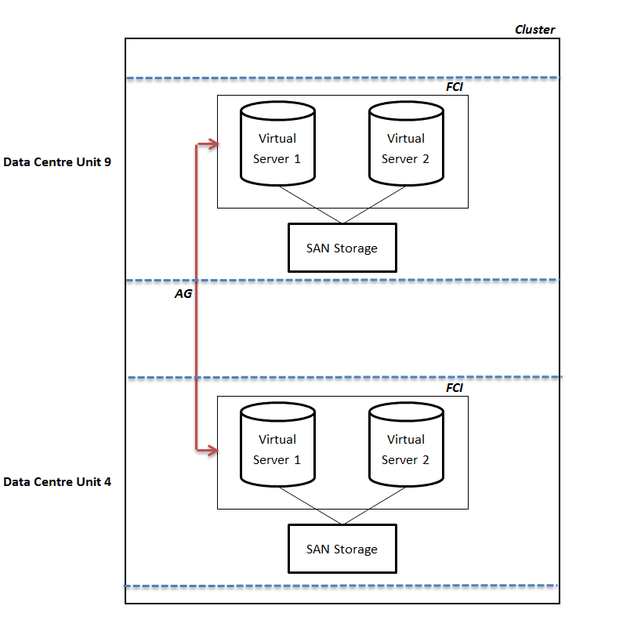

## Implementation Tasks

High level implementation tasks are:

* Rebuild existing unit 4 server with SQL Server 2014 Enterprise.
* Deploy upgraded unit 4 server.
* Rebuild existing unit 9 server with SQL Server 2014 Enterprise.
* Deploy upgraded unit 9 server.
* Create and add second server to unit 4 Failover Cluster Instance.
* Create and add second server to unit 9 Failover Cluster Instance.
* Implement additional SQL functionality as appropriate to further improve performance.

## Test Approach

Celtrak Database team will perform the SQL upgrade deployment to the Celtrak development environment to ensure no errors.

Celtrak QA team will perform a full regression testing.

No testing from Thermo King is necessary.

## Risks and Migration

Risk is that:

* There will be unanticipated errors encountered during deployment.
* There will be unanticipated errors encountered after deployment.

Migration of these risks should be covered by the following:

* Testing conducted.
* Rollback strategy:
  + During deployment to unit 4, there is the option of revert back to existing unit 9 server if any issues are encountered during deployment.
  + If issues are encountered after deployment that cannot be resolved, the database backups could be used to restore database to state before deployment.

## Deployment

Below are the deployment stages and outages required:

* Stage 1:

Deploy upgraded unit 4 server: **1 hour outage** required.

* Stage 2:

Deploy upgraded unit 9 server: **30 minute outage** required.

* Stage 3:

Create and add second server to unit 4 Failover Cluster Instance: No outage required.

* Stage 4:

Create and add second server to unit 9 Failover Cluster Instance: No outage required.

* Stage 5:

Implement additional SQL functionality as appropriate to further improve performance: This will be determined at a later date and will likely be implemented in conjunction with IT changes.